***Championship Ring Order Form***

***IWCOA – Hall of Fame Ring***

Name:

Address:   
 Phone: Email:

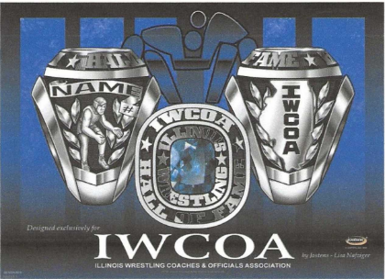

**Step 1 Metal Quality:**

White Lustrium (non-precious metal) $ 209

______ Suncast (non-precious gold toned metal) $ 249

______ 10 kt white gold $1479

______ 10 kt yellow gold $1479

**Step 2 Personalize:** *Ring Design: 8519X*

Name on Side of Ring:

*(14 characters max. including spaces)*

Year Inducted:

(3 characters max. including spaces)

Inside Engraving:

________________________________

*(two lines of 18 characters max. each including spaces)*

**Step 3 Select Ring Size & Stone Color:**

Size

Stone ___________

*(choice of simulated birthstone in garnet, amethyst, aquamarine, white spinel, shamrock, alexandrite, ruby, peridot, fire blue spinel, rose zircon, topaz, or blue zircon)*

**Step 4 Check Out:**

Ring Price

Delivery $14.95

Tax (6.25%)

***TOTAL***

Check #

Debit/Credit Card Number

Expiration Date CVV Code

Name on Card

Signature & Date

*Pricing valid until 12/31/22. We accept all major credit cards, debit cards, checks and money orders. Make checks payable to Jostens.*

**Step 5 Mail or Email by Dec. 31st to: JOSTENS Email:**

**PO Box 231 jan.slade@jostens.com**

**Bettendorf, IA 52722**